Computer Language Coding Concepts

Interfaces
Up till now the idea of interfaces was fully left out of the stories. This documentation makes the concept of interfaces catch up with the rest of the documentation. The basic concept of interfaces is covered along with its diagram notation. Also covered are: interface assignment, interface reference and relations that form through the use of interfaces. Another concept, yet to be worked out, is how commands of an object are grouped by site: an object can have commands, defined on different sites, and the commands should be grouped by site in order to judge how reliable the commands are (grouped by source). As interfaces can be applied to objects, interfaces can also be applied to commands.

This documentation is not finished. It is a throw-together of ideas, that are yet to be turned into good documentation.

At some point the idea was, to also cover all the different uses of interfaces. But the different uses of interfaces are adequately described by other literature. The focus will lie on explaining the raw concept of interfaces and their presence in the new computer language.

Author & Copyright: Jan-Joost van Zon Date: May 5, 2009 – May 2, 2010 Location: Oosterhout, The Netherlands Status: Finished

Interfaces Main Concepts
The main concepts of interfaces are explained here along with their diagram notations.

Interface = Publics
An object’s interface consists of all of its public members.

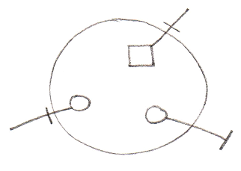

Interface & Implementation
An interface defines an object’s public members. The privates of an object are called the object’s implementation. So interfaces offers the ability to separate publics from privates, ergo separate interface from implementation.

Object:

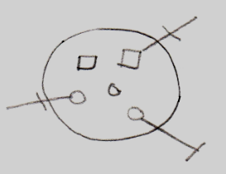

Interface:

Implementation:

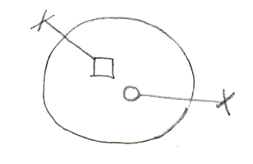

Interface = Objects Melting Together
Another concept which employs the word interfaces, is an object (an interface) melting together with its container.

This is displayed using a triangle object.

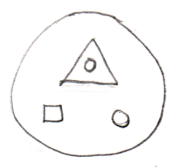

The memebers of the triangle automatically become members of the larger circle.

Interface = Contract
Interfaces also offer the functionality of being a contract.
You can establish this by defining the interface externally.

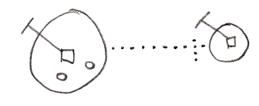

If an object has its interface defined externallly, the public contents of the object can not be freely changed. If the interface of the object needs to change, the externally defined interface needs to be changed.

Multiple Interfaces
If you want an object to support multiple contracts you can use several triangles inside the object and define their interfaces externally.

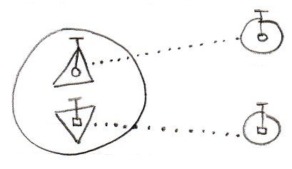

Interface Type Control
Interface type control should for instance occur when you reference an object and the reference has the wrong interface. Restrictions must then be enforced.

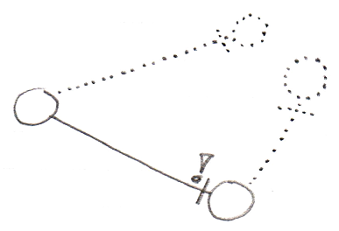

The situation above is not valid, because the reference does not have the same interface as the object it points to.

Interface Object Resolution
Interface object resolution happens when you reference an object and the reference has an interface defined, that the object supports. It automatically redirects the reference to the specific interface of the object.

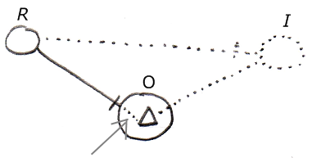

It is about the bit of dotted line denoted by the arrow. This is an automatic extension of the solid line on the left. Because the the reference (R) on the left has an externally defined interface (I) on the right, and the object (O) supports this interface, the reference’s line is automatically redirected to this particular interface of the object. Automatic redirections like that are called object resolution.

There are a lot of other object resolution concepts related to interfaces and inheritance, such as overriding and shadowing, but they will be covered separately in the Object Resolution chapter.

The situation above only works in case of implicit interfaces (explained elsewhere).

Below is another example of interface object resolution, but now in case of referencing a member of the interface, while not explicitly accessing the interface:

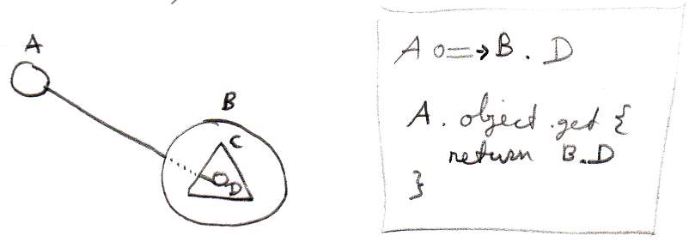

Again it is about the dotted piece of line in between, which expresses the automatic object resolution. Next to the picture is a bit of pseudo-code that expresses how reference A points to D without qualifying it with interface C.

Explicit Interfaces
You can speak of an explicit interface when you externally define a sub-object’s interface, you but do not let the sub-object melt together with the container.

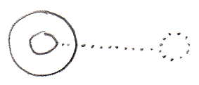

This requires you to refer to the interface directly in order to access it. A reference to the parent can not automatically resolve to a reference to the interface.

Implicit Interfaces
You can speak of an implicit interface when you externally define a sub-object’s interface, but you do let the sub-object melt together with the container.

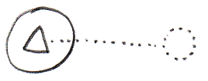

You can reference members of the interface directly through the circle, without explicitly mentioning which interface you are accessing (see Interface Object Resolution).

Inheritance
Traditional inheritance is related to the concept of interfaces. What happens is that an object melts together with its container and next to its interface being defined externally, the implementation is also defined externally. The result is classic inheritance: one object takes over all characteristics of another object.

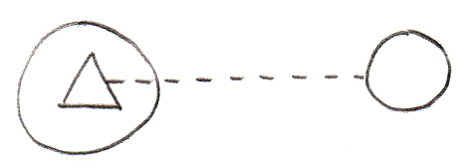

So because the triangle has an externally defined class (dashed line) instead of an externally defined interface (dotted line) the situation turns from implicit interface into classic inheritance. In the situation above one object inherits from another object. Expressing it more like one class inheriting from another class it would look as follows :

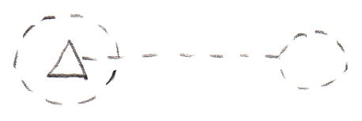

Classic inheritance is not the only form of inheritance in the new computer language. Different forms of inheritance are covered separately in the chapter Inheritance, but it is important to point out here, that classic inheritance and interfaces are closely related.

Main Usages of Contracts
When you externally define an interface, it becomes the concept of a contract. You can creatively use this concept for any purposes, but some of those purposes deserve to be pointed out explicitly.

It can be a contract of a guarantee to support a sure set of members. So this offers a guarantee to ones that will be using the object. So you know an object has at least those members with that exact configuration.

An interface can also serve as a contract of usage. So now someone using the object will only be able to use it in an exactly defined way. This means, that an object has exactly the members defined by the interface.

A powerful application of such a contract, is the interface as a contract of participation. This concept makes it possible to introduce new types of objects into a system, that originally was not aware of those types, but is aware of how to use an interface that all the types support.

Interface Aspect
While systems seem to be composed of a lot of different types of objects, all objects and types are in reality no more than a very limited set of types, that can be configured to look like other types. Those basic objects are called system objects. The behavior of those system objects is controlled by controlling their system aspects. System objects is covered in a separate chapter called System Objects, but there the interface aspect was completely left out of the story. In this part of the documentation everything about the interface aspect is laid out to make the concept of interfaces catch up with the System Objects story.

The Interface aspect allows you to control how objects look on the outside, while the insides of the objects can differ completely.
Another concept which employs the word interfaces is an object (an interface) melting together with its container. From a systematic point of view they seem to be completely unrelated concepts, however in practice they are conjoinedly used. To distinguish them we call them the Interface aspect and the Interface Merging aspect. The main diagram symbolization of the Interface aspect is as follows:

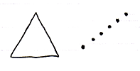

The triangle is the symbolization of the Interface Merging aspect, and the dotted line is the symbolization of Interface aspect.

Interface Merging will probably become an aspect that will extend beyond the concept of interfaces in the future, because it could for instance apply to the concept of default members.

System Commands for the Interface Aspect
The main system commands to control the Interface aspect are:

Use As Interface
Interface Set
Reference-Interface Set
Object-Interface Set

Use As Interface is like Object Get, but then for the purpose of using that object as the interface of another object. This is common usage of the interface aspect. It also makes you able to separately access control whether an object can be used as an interface.

The Interface Set command is executed on an object reference. The reference can then only point to object that supports the interface. This means either that the other object has the same interface, or that the object has it as sub-object that is an implicit interface. For now Interface Set applies only to references and not to objects, because the interface of an object can only be set upon creation. Perhaps in the future this rule will be broken, but for now that is the rule.

The commands Reference-Interface Get and Object-Interface Get get the interface object that is associated with a reference or object. Those commands are actually less commonly used.

Interface is both Object-Bound and Reference-Bound
The Interface aspect applies to both objects and references, but differently. An object has a certain interface, that is set upon creation and throughout its lifetime. A reference can also have an interface, defining which classes of object you can assign to the reference. The interfaces of an object can never change. The interface of a reference can be changed, but only to an interface supported by the object it points to or arbitrarily while the reference is Nothing.

Pointer-to-Pointer Situations
In a standard situation the Use As Interface, Interface Set, Reference-Interface Get and Object-Interface Get commands are about making an object function as another object’s interface. However, you can also make something’s interface be yet again another reference. That means that another parent object determines the eventual interface.

(However, this might create difficulty for the system to maintain an object’s constant interface. You might want another parent to determine the initial interface, but the interface of an object should not change during its lifetime.)

Set Interface to Reference
To be able to set the Interface aspect to another related item, Interface Set has two overloads:

Interface Set → Set Interface to Other Related Item.
Interface Set → Set Interface to Other Related List Item

If you want a single name to express both situations, you could call it Set Interface to Reference.

Get Interface which is a Reference
Because the Interface aspect can be set to another related item, the Interface Get command gets extra overloads. Next to that, there are different overloads for the two types of Interface Get: Reference-Interface Get and Object-Interface Get. This creates the following overloads:

Reference-Interface Get → Get Reference-Interface which is Another Related Item
Reference-Interface Get → Get Reference-Interface which is Another Related List Item

Object-Interface Get → Get Object-Interface which is Another Related Item
Object-Interface Get → Get Object-Interface which is Another Related List Item

You could also call them Get Interface which is a Reference.

Use Reference As Interface
The Reference aspect can be access-controlled for different ways you can use it. Pointer-to-pointer situations require you to be able to use a reference as an interface. To be able to access control the different purposes for which you can use a reference, the Reference Get command gets the secondary implementation:

Use Reference As Interface

which delegates directly to the Reference Get command.

The Overloads Recapitulated
Do not wreck your brain over all this delegation and overloading. It is just for pointer-to-pointer situations to have the same command names as standard situations, and also to be able to separately access-control the specific uses of references or objects. You will not usually see the pointer-related commands, because they will be implicitly delegated to by the main commands. This leaves us with the following commands:

Use As Interface
Interface Set
Reference-Interface Get
Object-Interface Get
Use Reference As Interface

Detail: For that last command you might want to overload Object Get. But that does not work. You can not overload it, because they will both take a pointer to an object as an argument. To disambiguate, they have to have a different name and you have to point to a specific command.

Commands for the Interface Merging Aspect
The commands for the Interface Merging aspect are:

Interface Merged Get
Interface Merged Set

Interface Merging is a reference-bound aspect: it only applies to references, not objects.

Interface Merged is a Boolean, that can be either True or False.

When an interface is merged it means that its members merge with its container and are accessible as if part of the container. Also, the container can be referenced as if it has the type of the interface.

Interface Aspect in System Interface
System aspects can be shown in the system interface notation as worked out in the System Interfaces articles in the System Objects chapter. The Interface aspect was not covered there, so this is a supplement to that documentation, covering it for the Interface aspect.

Object-Interface Aspect in System Interface of Object
The Interface aspect has five system commands, but only two of them apply to Objects. The other ones apply to references. The Interface aspect of an Object is controlled through the following commands:

Use As Interface
Object-Interface Get

The commands are placed inside the system interface inside a triangle that wraps together the members of the Interface aspect:

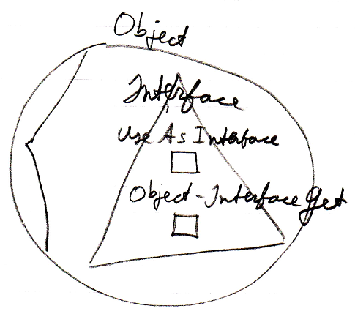

Reference-Interface Aspect in System Interface of Related (List) Item
The interface aspect has five system commands, but only three of them apply to Related Items:

Inteface Set
Reference-Interface Get
Use Reference As Interface

The commands are placed inside a triangle, that wraps together the members of the Interface aspect:

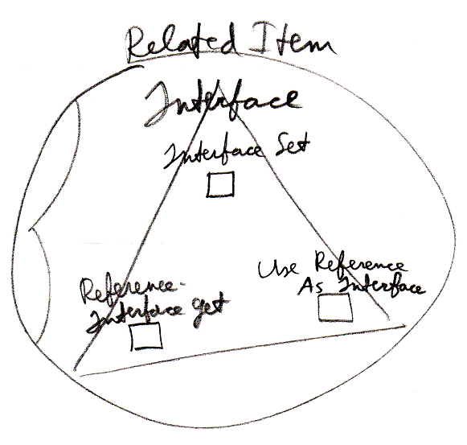

It works the same for a Related List Item as it does for a Related Item.

Reference-Interface Aspect in System Interface of Related List
A list can centrally control the aspects of its items. Therefore, a list can control the Interface aspect of its items, centrally setting the Interface that all the items must support.

The system commands to do this are placed inside a triangle that wraps together the members to control the Interface aspect:

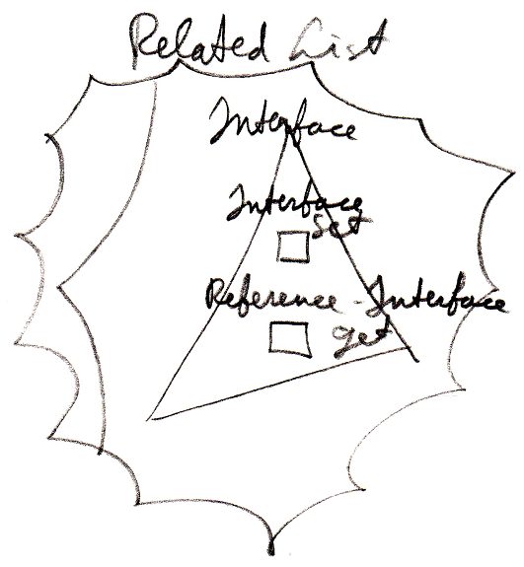

The Use Reference As Interface command is not present, because that command does not apply to the list as a whole, but only to a particular item in the list.

Interface Merging Aspect in System Interface of Related Item
The Interface Merging aspect only applies to Related Items. It is controlled through two commands:

Interface Merged Get
Interface Merged Set

The commands are placed inside the system interface inside a triangle, that wraps together the members of the Interface Merging aspect:

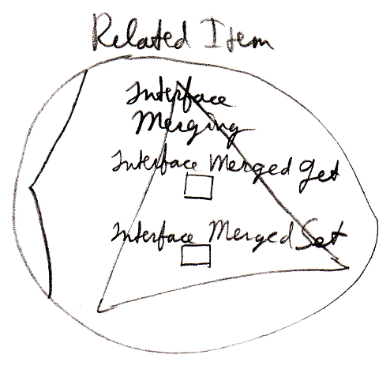

Interface Merging does not apply to Related List Items, because it does not seem to be practical there.

Interface Assignment Types
This section is a mere supplement to the Assignment articles in the System Objects chapter. For a general explanation of assignment, look there. This section only makes the Interface aspect catch up with the rest of the explanations.

Interface Assignment
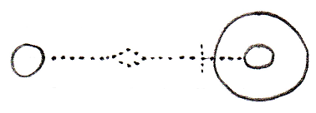
Use As Interface ← (~= Object Get)
Interface Set →
Makes the source become
the interface for the target.
Interface Pointer Assignment
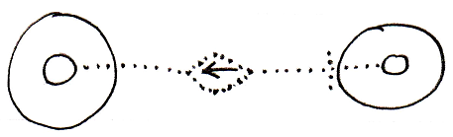
Use Reference As Interface ← (~= Reference Get)
Interface Set → (~= Set Interface to Other Related Item)
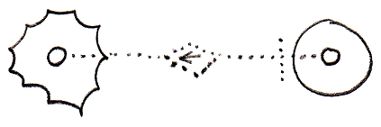
Use Reference As Interface ← (~= Reference Get)
Interface Set → (~= Set Interface to Other Related List Item)
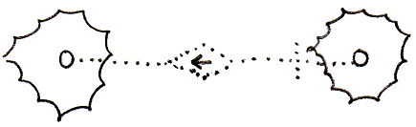
Use Reference As Interface ← (~= Reference Get)
Interface Set → (~= Set Interface to Other Related List Item)
Interface Assignment With Pointer Source
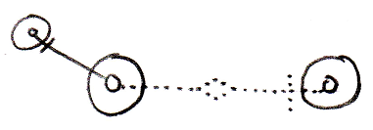
Use As Interface ← (~= Use Reference As Interface)
Interface Set → (~= Set Interface to Other Related Item)
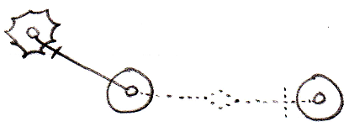
Use As Interface ← (~= Use Reference As Interface)
Interface Set → (~= Set Interface to Other Related List Item)
Cross-Aspect Interface Assignment
Object-Interface to Object Assignment
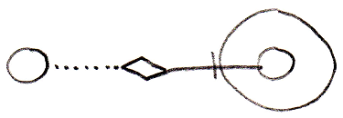
Object-Interface Get ←
Object Set →
Reference-Interface to Object Assignment
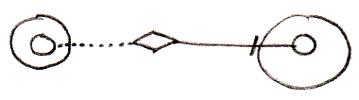
Reference-Interface Get ←
Object Set →
Object-Interface to Reference-Class Assignment
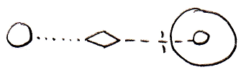
Object-Interface Get ←
Reference-Class Set →
Object-Class to Reference-Interface Assignment
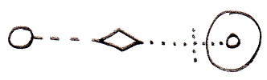
Object-Class Get ←
Reference-Interface Set →
Reference-Class to Reference-Interface Assignment
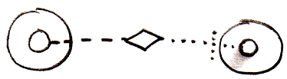
Reference-Class Get ←
Reference-Interface Set →

There are more implementations of the cross-aspect assignments for cases when the source of the assignment is a pointer-to-pointer, but they are not shown here. To understand the concept look in the Cross-Aspect Assignments article in the System Objects chapter.

Interface - System Command Call Notations
The concepts of system command call notations is not explained here. Refer to the System Command Call Notations article in the System Objects chapter for that. this is a supplement to that documentation, covering it for the Interface aspect. The Interface Merged aspect is also covered.

Cross-aspect situations can apply to the Interface aspect, but they are not covered. Cross-aspect situations between the Object and Class aspects are described in the System Objects chapter and adequately shed light on the topic.

Interface – System Interface - Command Call Notation
Only one example of a call to a system command of the Interface aspect using the system interface notation will be given here. Below you will find this notation for a call to the Object-Interface Get command:

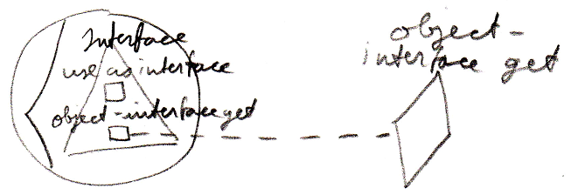

Interface – Simplified System Command Call Notation
Below you will find the various types of calls to a system command on the Interface aspect in the simplified system command call notation.

Use As Interface | Use Reference As Interface
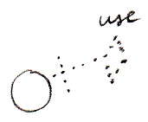 | 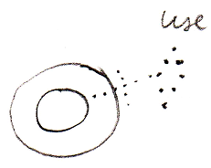
Interface Set
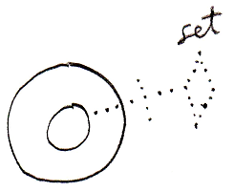
Object-Interface Get | Reference-Interface Get
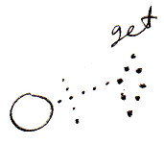 | 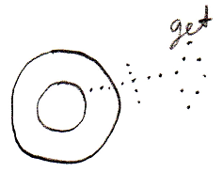
Interface Merged Get | Interface Merged Set
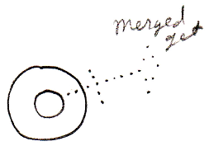 | 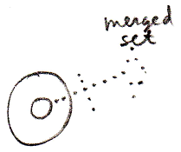

Interface – System Command Call Notation with Argument
Below you will find the various types of calls to a system command on the Interface aspect in the system command call with argument notation.

Use As Interface | Use Reference As Interface | Interface Set
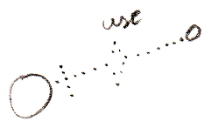 | 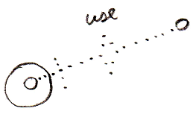 | 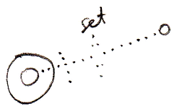
Use As Interface ←  (Interface Set →) | Use Reference As Interface ←  (Interface Set →) | (Interface Get →)  Interface Set ←
Object-Interface Get | Reference-Interface Get
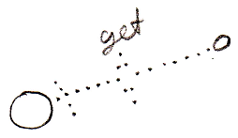 | 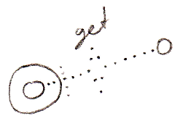
Object-Interface Get ←  (Interface Set →) | Reference-Interface Get ←  (Interface Set →)

Interface Merged Get | Interface Merged Set
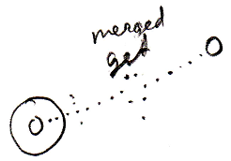 | 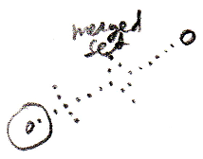
Interface Merged Get ←  (Value Set →) | (Value Get →)  Interface Merged Set ←

(For the Interface Merged commands the argument is a Boolean.)

Interface – Explicit Get & Set Notation
Below you will find some examples of the explicit Get and Set notation working on the Interface aspect.

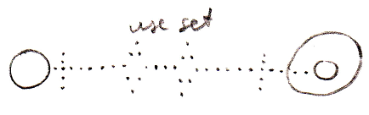

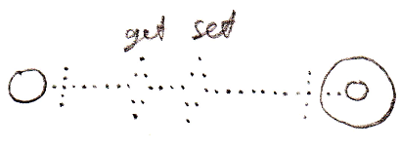

Interface – Explicit Get & Set Arguments Notation
Below you find various notations where Get and Set arguments are explicitly drawn out, where the Interface aspect is adressed.

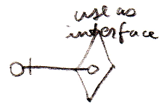

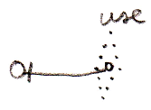

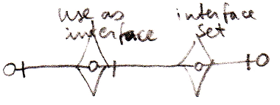

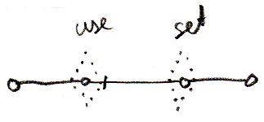

Interface Connectors
Below you will find an overview of the possible connectors concerning the Interface aspect and the Interface Merged aspect.

Use As Interface | Use Reference As Interface
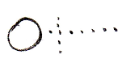 | 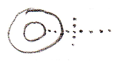
Interface Set
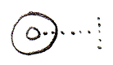
Object-Interface Get | Reference-Interface Get
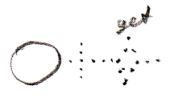 | 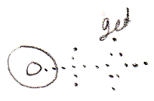
Interface Merged Get | Interface Merged Set
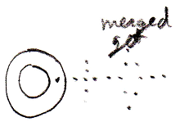 | 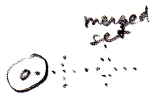

Interface Connections
Below you will find the possible connections for the Interface aspect and the Interface Merged aspect. A connector is a result of a call to a system command. However, the result of call to the Interface Merged Set command is that the reference becomes a triangle or a circle shape. This result is also presented in the overview.

Use As Interface | Interface Set
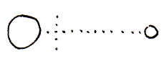 | 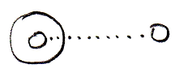
Interface Merged = True |  | Interface Merged = False
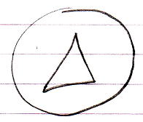 |  | 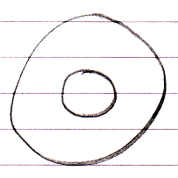

Reliability of Interfaces
An interface is a contract. A welcome fact about a contract is that once agreed upon, it does not change. So an interface should be reliable.

However, in the new computer language the concept of relations can make interfaces unreliable.

Relations are bidirectional. When something points to something else, the other thing points back. This causes extra members to be dynamically added to the interface of another object. The interface of one object changes when other objects start pointing to it.

So get rid of backward relations? No. The benefits from bidirectional relations are too important. They solve a difficult fundamental problem in computer technology. A lot of times you want to know whether an object is still used and what specifically still uses this object. In computer systems today this is often difficult to find out. Knowing all backward connections all the time would solve this problem.

Another concept that springs to life by employing bidirectional relations is the neat phenomenon, that when a command has parameters, the command is immediately available from any object that the command could be executed on.

To keep interfaces reliable, backward relations should not automatically become part of the interface. The solution is to make the backward relations Private. This disincludes the members from the interface, and only makes them part of the implementation.

Other options have been proposed to responsibly get rid of the automatically created members. All the options will be explained now.

Backward relation options:

- Private
- Public
- Manual
- Conditional
- Preliminary

Private backward relation

Allowing backward relations but making them Private means the backward relations are maintained, but they do not become part of the interface.

Public backward relation

Allowing Public backward relations means the interface will not be stable, because extra members are created when things start pointing to an object.

Manual backward relations

In this case backward relations are not created automatically. Logically this keeps the interface stable. You can program the backward relation later, but only if you know where the foreward relation is. To find all foreward relations them all you may just need to scan the entire earth, so it is not easy.
When you are able to program the relation back, you also need permission from the foreward relation, because this could have great implications on the way the other object functions.

Maintaining a backward relation should be strongly stimulated because it solves such a difficult fundamental problem in computer technology. To equally honor the values of both the interface concept and the relations concept, the default solution should be to make backward relations Private. Keeping backward relations Private keeps interfaces stable.

Now follow some other solutions, that are sort of arbitrary and miscellaneous, but possibly handy in practice.

Conditional backward relations

Perhaps you should automatically accept backward relations based on a condition, for instance that the relation counterpart is within the same module.
It may be a neat editing feature. That way you can program a module and let backward relations build up, but outside sources can not influence this process. This limits control to interface extensions to the module itself. In a broader sense you are defining a condition for automatically accepting a backward relation: namely that the relation counterpart must be inside the same module.

Preliminary backward relation

Preliminary backward relation means that the foreward end of the relation will maintain the backward relation until the relation counterpart either accepts or refuses it. This politely keeps the other related object’s interface and storage in tact while still offering the ability to adopt the index. You may also solve a quota overrun security problem this way.

This sounds good in theory, but in practice it may turn out that the registration of the request takes the same amount of storage as storing the backwards relation itself.

Imaginary Backward Relations
Sometimes when a backward relation is not stored, you want to see it anyway. Particularly: you always want to see all available commands inside an object. Even though an object does not physically have a reference to all the commands, you want them all available inside the object anyway.

This requires backward relations that are not stored, to be shown anyway.
The solution is to draw them out as imaginary backward relations.
This requires some recalculation whenever the view changes.
But this is only done for related commands and objects inside modules that you actively reference.
You still will not have all possible commands on the internet available inside the object, but you do not want that anyway, because that would be a ridiculous amount of commands. You just want the ones from sites that you are aquainted with.

Command Interfaces
This article is here to point out that commands can have interfaces just like objects. A command having an interface approximates the same functionality as C++ function prototypes or delegates in .NET. Only in the new computer language it much more is possible. Because a command is an object, any interface concept is applicable to commands as well.

Here is your basic function prototype concept expressed in a new computer language diagram:

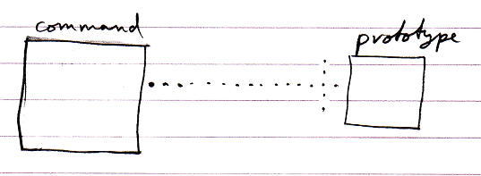

Here is the example when the command has a paramater.

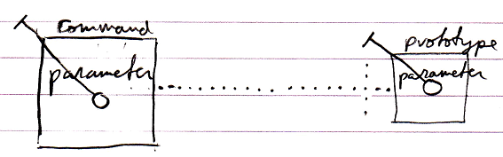

The implementation of the command can be different from its function prototype:

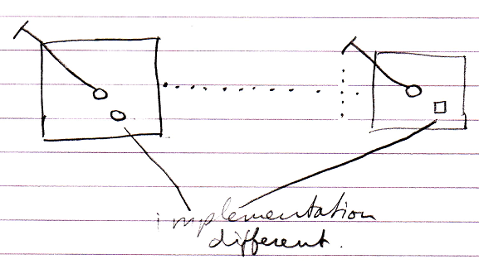

But this was classic C++ function prototype. The new computer language has more possibilities when it comes to command interfaces, some of which are displayed below.

Command inheritance:

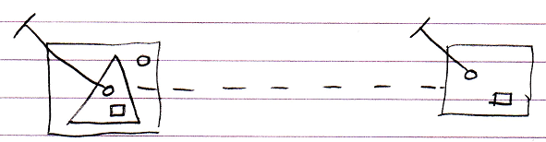

Multiple command interfaces:

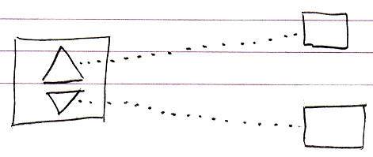

So basically anything regarding interfaces that can be done with objects, can also be done with commands.

Member Grouping
Triangles could be used to indicate a benign member grouping:

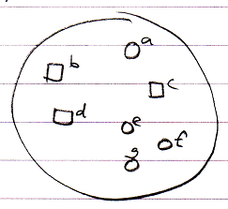 | → | 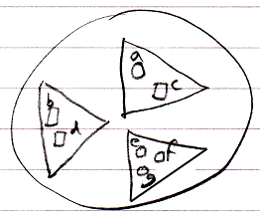

At first glance the grouping does not seem to affect how the objects are used.

However, two problems arise:

- Explicit interface dependency
- Call overhead

Below these two problems are explained and possible solutions are given. Solutions for these problems are still very much open to discussion.

Explicit interface dependency

Existing functionality may not be affected by member groupings. However, you could make new connections directly to the new interface objects.

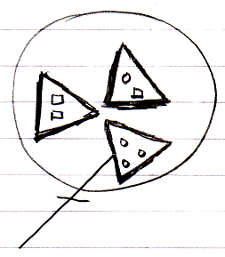

The new connections are now dependent on the member grouping, which was only meant to be a loose definition.

To allow member grouping to be benign, some solution must be found for this. The solution probably lies in the area of access controlling system commands. The member groupings need to be access controlled enough to not be able to explicitly connect to them, but not so much that it makes their members totally inaccessible. Separately access controlling Get For Access and Get For Copy might solve this problem. However, it needs to be thought through if this really only blocks something’s usage as a qualifier. If it does not, probably another split up in system commands will do the trick.

Ideas about the separation between Get For Access and Get For Copy can also be found in the Black Box chapter and the System Objects chapter.

Call overhead

Member grouping may seem benign, but when you approach a member of a group, an Object Get command on the group must be executed before accessing the member, which causes (a small) processing overhead on the call.

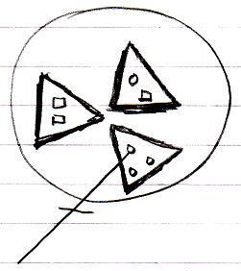

The solution could either lie in optimization, or making the triangles imaginary.

Imaginary elements of a diagram were introduced in the Automatic Containment article. Making the member groupings imaginary might be a bad idea, because up until now imaginary elements of the diagram were calculated by the system, and not set by a programmer and it might be wise to keep it that way.

A better solution may lie in optimization. Programmers often add structure to their programs even though it is not absolutely necessary, but just makes things more tangable and orderly. Taking such structurings out of a program before it is run, is more of an optimization issue than anything else.

Interface Referencing and Redirectioning
This article contains examples of what diferent interface referencing and redirectioning situations would look like in a diagram and what name we could give to this situation.

Interface Reference

An object’s specification of which interface it has, is also called an interface reference.

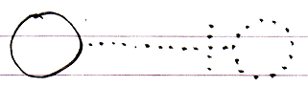

Command Class Interface

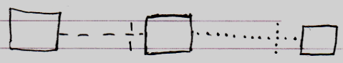

Class Command Interface

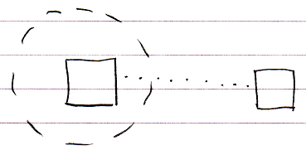

Command Definition Interface Redirection

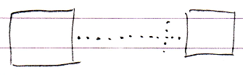

Command Reference Interface Redirection

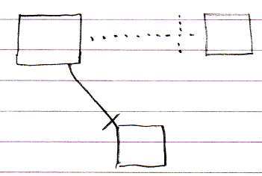

Command Call Interface Redirection

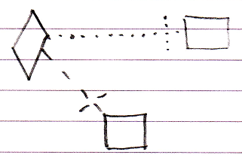

Active Clause Interface Redirection

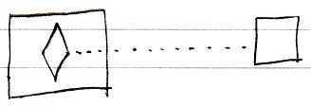

Inactive Clause Interface Redirection

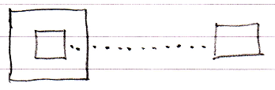

Target Interface
The target interface is found by following a number of redirections to find the actual interface object that the publics of an object are based on.

To find the target interface, you first follow all the object redirections, then a maximum of one class redirection, then all the object redirections again, then a maximum of one interface redirection and then all object redirections again, and there it ends.

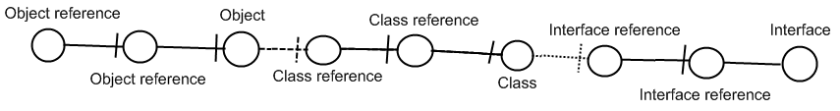

Here is an example where there are no class lines involved:

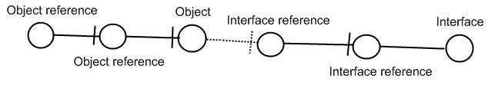

If the interface has an interface as well, this does not redirect the original object’s interface, because the second interface is another interface object, that the first interface is just based on. An object redirection is just a much tighter bond, than a class or interface redirection.

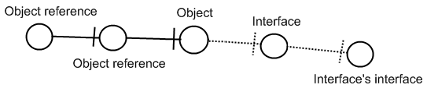

The target interface of the object reference is the symbol Interface, not the symbol Interface’s interface. So you should not follow more than one interface redirection to get to the interface object.

You should also not follow more than one class redirection to find the target interface. If the class has again a class which has an interface, the first class does not have an interface defined at all:

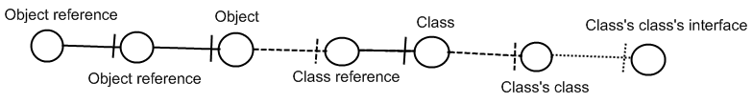

The last symbol Class’s class’s interface is only the interface of Class’s class, not the interface of Class. So Class is where the interface redirections end.

Also, you should follow one class redirection and one interface redirection in that order. Here is a less logical example, in case of which you do not follow the last class redirection:

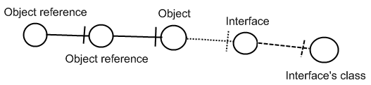

The last symbol may eventually define the interface, but it is still Interface which is the Object reference’s interface object.

Relations Though Interfaces
The most fundamental relation is a relation between two objects: one object contains a reference to another object, and the other object contains a reference back to the first object.

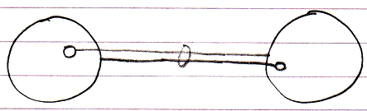

Classes can put control on which other class they are related to.

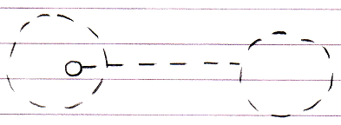

The effect is that in an object of that class, a specific reference can only point to an object of a specific other class.

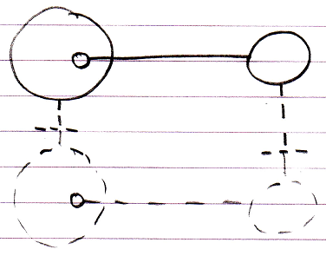

This is merely type re-enforcement. The picture below shows the classes in a bidirectional relation.

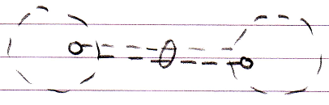

The example above illustrates what we call a relation between two classes. This relation between classes can be ‘felt’ throughout the object structure and is ultimately defined inside the classes.

Relations through interfaces is the same concept but now applied to interfaces. There are two possibilities.

The first possibility is that a class defines the interface of one of its references.

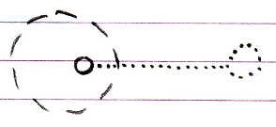

In that case it is said to be a relation between a class and an interface.
An interface can very well have a relation back to the class.

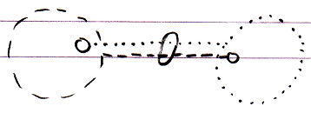

The effect of it is that objects that have that class or interface can only refer to an object of that a specific interface or class.

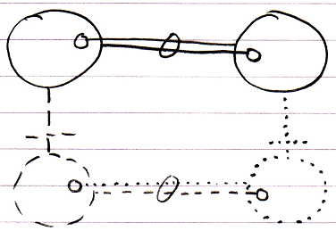

The second possibility is that an interface defines the interface of one of its references. And the other interface defines the relation back.

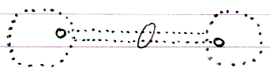

In that case it is said to be a relation between two interfaces. The effect of that is, that in objects with that interface, a specific public reference can only point to an object with that specific other interface.

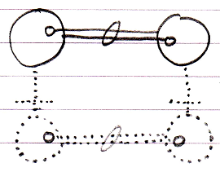

That is all there is to it. Relations between classes and interfaces are shear type-control on the relations between objects. Also, the mutual references are kept in sync, so that the two references always mutually point to eachother and not to anything else (that’s what the ring is for).

Group By Source
Your class can automatically be extended with extra commands from other sites, if you allow other sites to form bidirectional relations with your class.

The following foreward relation:

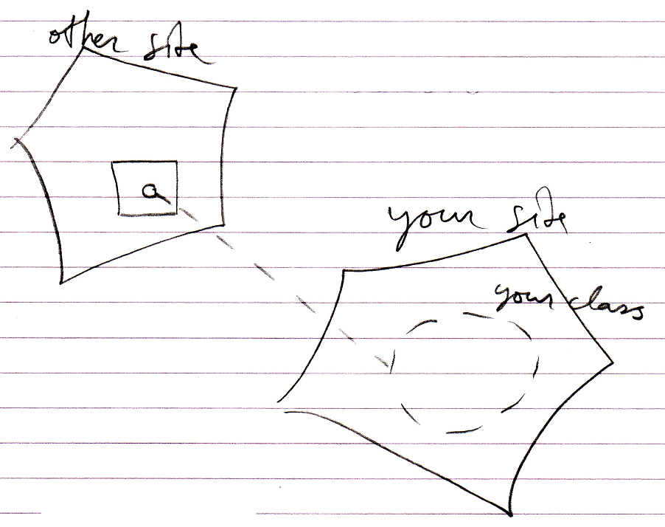

Can add a backward relation:

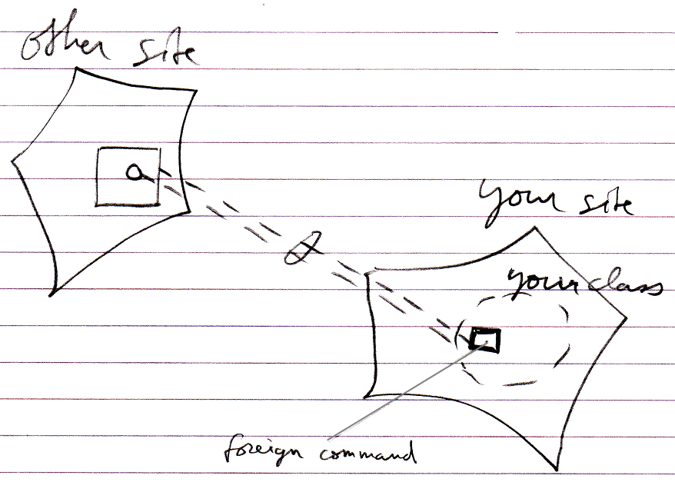

This creates an extra command inside your class, that is defined on another site.

The danger arises, that your class gets extended with commands that are not from a reliable source. To battle this danger a mechanism of control may need to be imposed.

The group by source concept is such a mechanism. Group by source introduces imaginary interfaces that group related objects by the site.

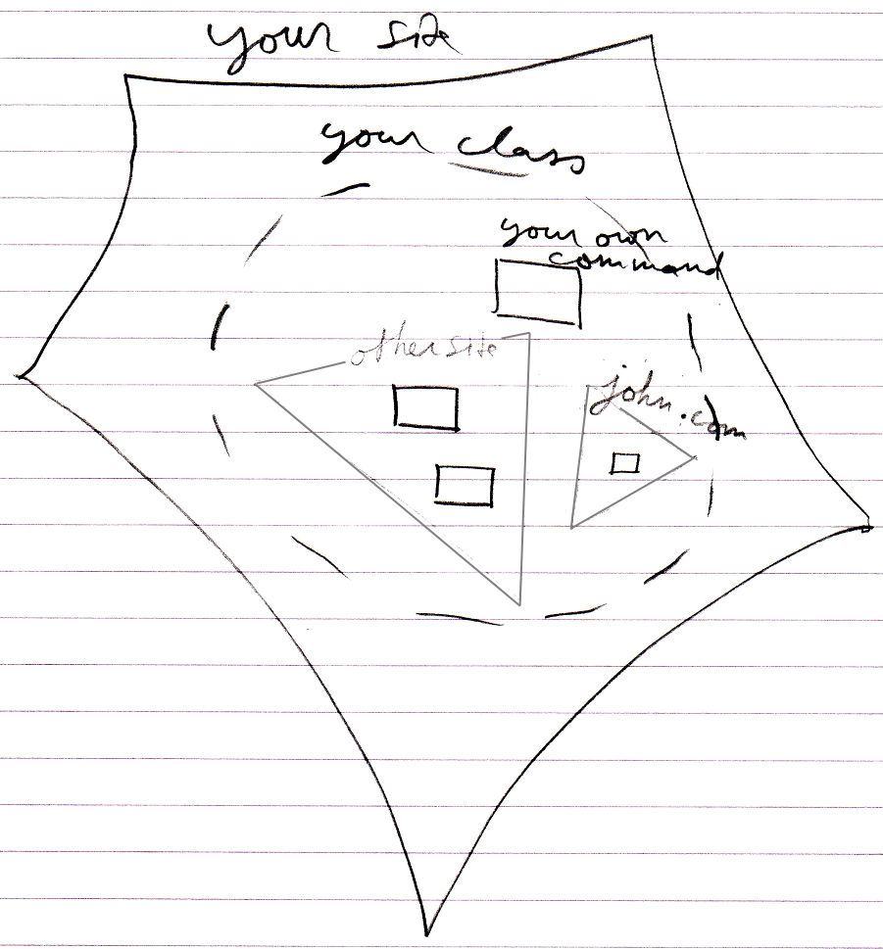

This means you get to see which site commands are defined on.

You have to be aware of what site a command is from and estimate if your consider this site reliable before you run a command. You have to do with the whole internet now, so you have to be aware of where stuff comes. This counts for everything: commands, classes, objects, modules. You just need to be aware what site you are accessing and whether you consider it a safe source.

Perhaps the concept of group by source can be inspiration for grouping by other sources than site, like group by module for instance. Perhaps this concept can also be inspiration for being able to a apply a custom imaginary grouping for other analysis purposes.

Ideas

The texts below are loose ideas yet to be turned into good documentation.

Reliability of Interfaces
2008-09-23
These sections came out of the old document Commands & Classes Loosely Coupled.

One thing about these sections is not right anymore. Spontaneous extension of interfaces does not only apply to commands. It also applies to backward relations, that can spontaneously come about when you make a relation to something.
However, anything else in the sections may very well still apply.

The sections were written around 2008-05-18.

Reliability of class interface
When you use a class, you expect the class to have certain commands; you expect it to have a certain interface. But anyone can add a command to the class now, just by using it as a parameter. If a class gets extended with commands every time you use it as a parameter, the class’s interface changes all the time. This suggests, that a class’s interface is unstable, and not reliable anymore. The data stored inside a class does not change suddenly like that <2008-09-06 This is not true at all. If you establish a dual relation with an old class, the old class will get a new member.>, but the set of commands accessible through the class can change all the time. What if somebody deletes his command, while everybody was using it, everybody thought it was part of the class, and then all of a sudden it’s not there anymore, and all the dependencies do not function anymore.

However, interfaces in other systems are just as unreliable as in this system, as this section will explain.

If you use a command through a class, you have to be aware of what site the command is part of. You have to be aware, that the class and the command may be authored on a totally different sites. You can see in the diagram on what site a command resides, compared to the class. In diagrams and in text code, things can be given a different color, depending on what site things are coming from. If the command and the class are from the same site or even the same module, the command may be more dependable, than a command from another site or module. You may be using commands, that don’t have a very reliable source. If you want to use commands from other sites, you’re just going to have to know the sites. If you use a command from a vague site, that didn’t even give the command a fixed logical residence, then the command is not reliable.

Reliability of external sources compared to traditional computer software:
> This is defense, but perhaps a good point.
A command can only be reliable, really, when the people authoring and using the command have a clear agreement about it. That is no different in other systems. Somebody hosting a web service could very well change the interface of the service, and have software, dependent on that service, crash. The only reason that wouldn’t happen, is because people have an agreement with eachother, not to change the interface just like that. And at times it does change unannounced, it really means systems will have problems.
Even interfaces of components on your local machine are only stable because of the agreement between you and the producer of the component. If they decided to automatically update the component, the interface or behavior of the component may very well change, and this may cause problems for your software. When it doesn’t, than this is because of the agreement, that you have with the other party.

If you access a command through a class, and that command is hosted elsewhere, you have to know you can trust that other site.

If you want more stability and control over the software you are using, you could always host a copy of a dependency (if you are able to copy it). This is analogus to having a software component installed on one of your own machines, instead of accessing a remotely running software component.

This explains, that a command automatically extending a class, does not make interfaces less reliable than they are today. The next sections explains more about how separation of interfaces is used to make classes more reliable.

> 2010-05-03: I am mixing two things up here: automatic extension with commands and how stable people are willing to keep their interfaces. Automatic extension changes an interface from the outside.
But the argument is that the changes are grouped by source. But it is no more than a backward relationship so once the bidirectional relationship is established, the command is part of the interface itself. The definition may be on another site, yes, that you could see when you apply the group-by-source thing. But these grouped interfaces are a whole lot more volatile than suggested here.

Mutual interface through mutual command

Mutual commands, mutual interfaces
<

Brainstorm 2010-05-06

The idea described here is not what I want in practice. However, perhaps some derived concept could prove its use.

Perhaps you should be able to define some sort of generic interface.
If you define an interface with a command in it, that has a certain class, perhaps with some sort of mechanism or construct you should be able to reference any object that has a command with that class. You will get in trouble if an object has two commands with the same class, though.

One of the ideas behind this is idea is that objects, that have the same command, because they are both parameters of the command, have a joint interface, to create a relation. But really, they already have a relation, just an indirect relation, which is also a relation.

This idea just does not work. It only works if you assume that a command definition is unchangeable and that class references to the same command actually have to be the same procedure, but it hasn’t. You have have a command referenced twice that has elements to it that can still be redefined. Some part of the procedure could be data, that is part of the interface, so changeable.
When this would no be the case then yes an idea like objects with the same command have a mutual interface could work, but in dynamic circumstances that are possible in the new computer language I just want to forget about it.

>

A command is an interface
If multiple classes can support the same command, then the classes support the same interface: an interface that has only one command. The interface is represented by the command itself. Each command implicitly creates an interface. That is how it is expressed in a diagram too: a command implicity creates an interface.

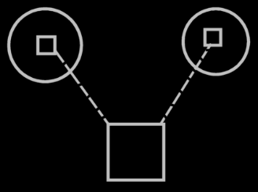

You don’t see triangles around the commands inside the circles, that would specify, that it is a separate interface: each command automatically becomes a separate interface. Just like each object also defines an interface; even though there is no triangle directly inside it, it still has an interface.

Multiple classes can support the same command
As you could see in the previous section: multiple classes, that support the same command, also support the same interface. Multiple classes supporting the same commands logically seems to create overlap in interface, but it doesn’t look like overlap in the diagram.

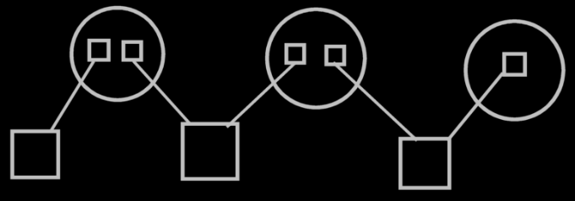

There are just multiple imaginary interface definitions (the circles), that each reference a different set of commands.
So a class referencing multiple commands, referenced by multiple classes, creates a visible interfaces of the class. The visible display of this interface is there, when you display the commands as part of a class, and not when you display the classes as parameters of the commands.

Command extending a class from another system
If two different sites define commands for the same class, this creates two interfaces for the class. If more commands for that class are defined on another site, this creates another interface for that class. This groups the commands of a class by source. That makes it so, that classes can be extended with commands very easily and suddenly, but interfaces don’t change that suddenly. Imaginary interfaces seemingly bring more stability to interfaces. Imaginary interfaces are author-bound, so one clumsy author can not mess up an interface authored by the one that authored the class himself. However, do remember that the real protection to a volatile interface is making backwards relations private or not automatically establishing backward relations at all. With commands coming from another site, it looks like the class has several command interfaces: one for each site.

It doesn’t need to be a site, that is the logical residence of a command; the logical residence of a command theoretically could also be an object. Each object, that locally defines commands for a class, creates a separate interface for that class.

That way, to extend a class with commands, you don’t need to create a derived class anymore. You can extend a class by simply creating a command that has that class as a parameter. But to extend a class with more data, you do need to create a derived class.

> 2010-05-03: I am still mixing things up here. It is good that the commands are grouped by the site that author’s the command, but the unreliability of interfaces also applies to backward relations that are automatically established. (This stuff must have been written before I worked out Commands & Parameters being no more than a relation between objects and commands.) Ok, then the backward relations are grouped by the site that authors their classes…
Giving each site an actually different interface does seem nice and does stabalize things.
However, I want to be able for an object as a whole to refuse addition of additional members, because that is what defines an interface: an object whose set of public members is fixed and will not get extended.
I can have an interface by source but then this interface should not be extended.
It is a good idea to group the members by the source that defines their class, but it is not a solution to the whole problem of unreliability of interface.
> I guess this story of group by source is only given as a possible solution.

Side-issues
The interfaces an object supports are interesting. It’s also interesting to know if an interface is supported by an object. Ofcourse you could derive that from the first data, but that’s not the fastest.

Ideas to Organize

Out of Commands & Classes Loosely Coupled

Preventing class’s extension with commands
A class can prevent itself from getting further extended with commands. For instance, you don’t want the class Integer to be extended with any command that uses an integer. It is a question of it being rediculous to maintain a list of all commands that uses integers. Don’t prevent a class from being extended with commands, just because you think it makes your interfaces more reliable. Class Integer can also just make it a default, that it doesn’t get further extended with commands. Some commands that use Integer, you might indeed want to see added to class integer, but you need to actively choose that then. If parameters don’t extend a class with a commands, these parameters are only shown as parameters, and not as commands inside a class definition.
> 2008-09-06 This is actually a non-dual relation.
This is basically the same issue as covered in the section Dual & Unary, which explains, when it is rediculous to maintain a backward relationship. For instance: relationships from class Integer back to any class, that uses an integer are rediculous to maintain as well.

Two design dangers
There are two design dangers here: at present day, everybody that knows his way with classes, is used to the fixed logical residence of a command inside a class, and everybody is used to not having his class be extended with commands all of a sudden. There is the danger that people using the new computer language, will give commands a fixed logical residence in a class, and turn on the option not to extend the class with commands. But you’re not supposed to do that! Not fixing a command to a class offers flexibility without unreliability. A class automatically getting extended with commands offers flexibility without unreliability. Perhaps it can be prevented, that people make these design mistakes. Perhaps by only allowing a command to be defined inside a globality, and by only being able to define it as a default, that a class does not get extended with commands, a default that can always be overridden.

Class data & class commands target definitions
A logical target class only defines data, not commands.
The data and the commands are defined by an imaginary target class. This imaginary target class is defined on a higher level than the logical target class. The class’s imaginary definition resides on a level, that’s above all the sites that define commands for the class.

The logical target class only defines data because commands are too freely definable. Other commands can be way out of sight, on a totally different site, that the class isn’t even aware of. Consider that an object in real life is defined in shape and form, but you can always invent a different use for the object: the object itself doesn’t need to change for that.

The residence of the imaginary class definition depends on the level of detail that you see in the diagram.

The target definitions of commands, as opposed to target definitions of classes, have separate target definitions, separate from the class definitions, and the class commands only indirectly refer to target definitions of commands. The picture below visualizes the concept of class data and class commands target definitions.

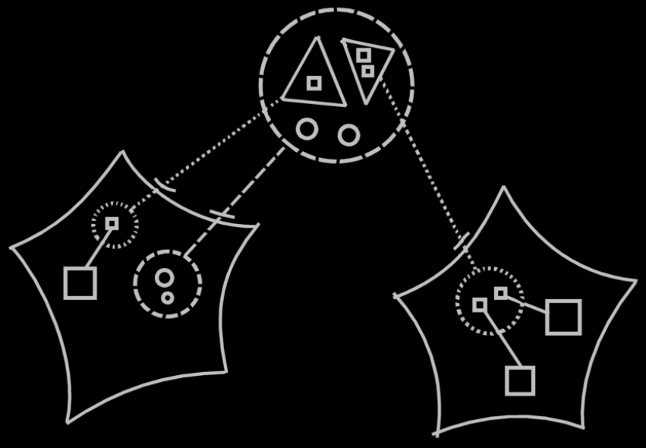

The large dashed circle at the top of the picture represents the imaginary target class, which contains both data (the little circles) and command interfaces (the triangles). The data is part of the actual class, which contains only data. The logical target of this class resides in the site on the left and is represented by a dashed circle, to which the imaginary target class points with a class line. The two command interfaces inside the imaginary class definition at the top of the diagram each point to another site’s command interface. The automatically created command interfaces aren’t real objects. they are imaginary objects. They don’t really exist as objects. Finally, the target command interface definitions on the sites, each contain references to commands defined on that site.

Looking at it like that, you can easily see that a class has several interfaces, but the interface is defined elsewhere, and an interface is definable elsewhere.

The notation above is a clear display of what is going on, but it may not conform to the eventual rules of notation of the diagrams. A discussion about the diagram notation is beyond the scope of this article. The diagram is only intended to clarify the concept.

In the diagram above you can see, that the command interface in the second site, is part of a class on the first site. But what if you zoom in on the second site:

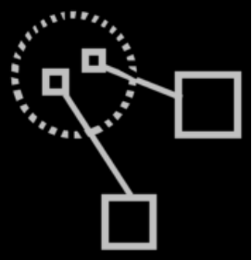

You no longer see the class itself on that level. You need to express somehow, for what class the command interface is defined. The solution is to have an imaginary reference to the class in view. If you define command for a class somewhere, then an imaginary reference to the class needs to be there:

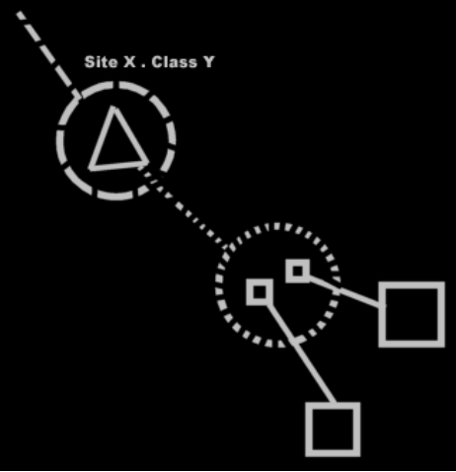

Now an imaginary reference to the class is there in the diagram, the logical target of which is specified by its name (Site X . Class Y), and it is pointing out of the diagram to indicate the target is out of sight.

Commands in class reuse with inheritance
It used to be an issue if inheritance would still be reliable, when a class’s set of commands can change so easily. The issue was: how does the ‘unreliability’ of a class’s composition affect inheritance? But now we have seen, that the total set of commands of a class may change volatilily, but a specific interface of a class does not change that volatilily. Each site specifies a separate interface of commands for the class, and these interfaces are as reliable as the site itself, and don’t change that suddenly.

The thing is: you shouldn’t really see the commands as part of the class. Only the data is part of the class. Commands are only imaginarily part of the class. In inheritance the data is inherited from the base class.
> 2008-09-06 This is not true, because if you establish a dual relation with a class on another site, the data of the class on the other site gets extended.
Also, in inheritance every command available from the base class will be available in the derived class. If interfaces or commands from the base class change or get deleted, they also get deleted from the derived class. The interfaces are just as ‘unreliable’ in the derived classes as they are in the base classes. But they’re not that unreliable, as we’ve seen. A class can easily get more interfaces, but an existing interfaces are as reliable as the site the interface is defined on.

Commands in reuse of interfaces
It also used to be an issue, whether the reuse of interfaces would still be reliable, when a class’s set of commands can change so easily. Every object symbol was able to serve as an interface, so when an object’s set of commands can change so suddenly, what good is it to use the object as an interface definition, that defines the expected interface.

The full command interface of a class may be unreliable, but a specific command interface of a class is not. You will be more likely to reuse a specific command interface of a class, rather than to borrow the whole command interface of a class as an interface.

Extensive classification with interfaces
A command implicitly creates an interface: an interface that has only one command. When commands for a class are implemented on a site, this also creates an interface for the class. These interfaces are defined automatically. Commands & classes loosely coupled creates interfaces, that already have an implementation. You are not borrowing an interface from elsewhere, and then giving it a new implementation.

Rules for extensive classification through interfaces will be discussed in the article Extensive classification through interfaces. Extensive classification through interfaces is about automatic definition of interfaces, as well as manual definition of interfaces. (Consider the imaginary group-by-source interfaces, which could be suggestions for interfaces to form). There may be more automatic definitions of interfaces, than just the one concerned with commands & classes loosely coupled, but this will be discussed in Extensive classification through interfaces.

Conclusion
Perhaps there will be other ways interfaces will be automatically defined.
Such as mutuality of commands creates mutuality of interfaces,
and that different sources of commands are seen as different interfaces for a class, which makes interface of a class reliable, even though the full set of commands of the class is very variable.

More Ideas
Commands & Classes Loosely Coupled,
> Moved to Interfaces, to be thought through there.

Making a command part of multipe objects,

But in their bare form commands are independent entities. If a command has a parameter, that does not have a class, the command becomes available from any object that has access to the command, yes.
If a parameter does have a class, then the command becomes available from any object of that class.
> 2008-09-24. That’s strange. Maybe not. If a parameter does not have a class, then the object inside the commands is uniquely related to tha command. So in this setting, in order to make a command available inside the objects of a class, you have to give the parameter a class, or the command could only be called as an independent entity? Wouldn’t it?
But in essence, a command is a separate entity. Making it also part of objects and classes, is secondary to that.

Perhaps you do have to actively aquaint sites with objects with other sites, so that they either index eachother, or scan eachother, at least: scan a limited amount of the internet, not the whole internet, that is undoable.
> 2008-09-24 I have to think about this. It’s not indexed, it’s a class relation. And if changes to the class are ventilated to all the objects this happens with the help of events, but usually you’ll just use versioning to use an unchanging production version of a class.

JJ

± 2008-08

But command as a concept, as a way to establish interchangability between class commands and command parameters, also needs to subdivide the class commands into interfaces: one for each module commands are defined in.
How that is established by command as a concept is yet to be determined.
> Interfaces

JJ

Another example diagram
Class with two method interfaces from different sites

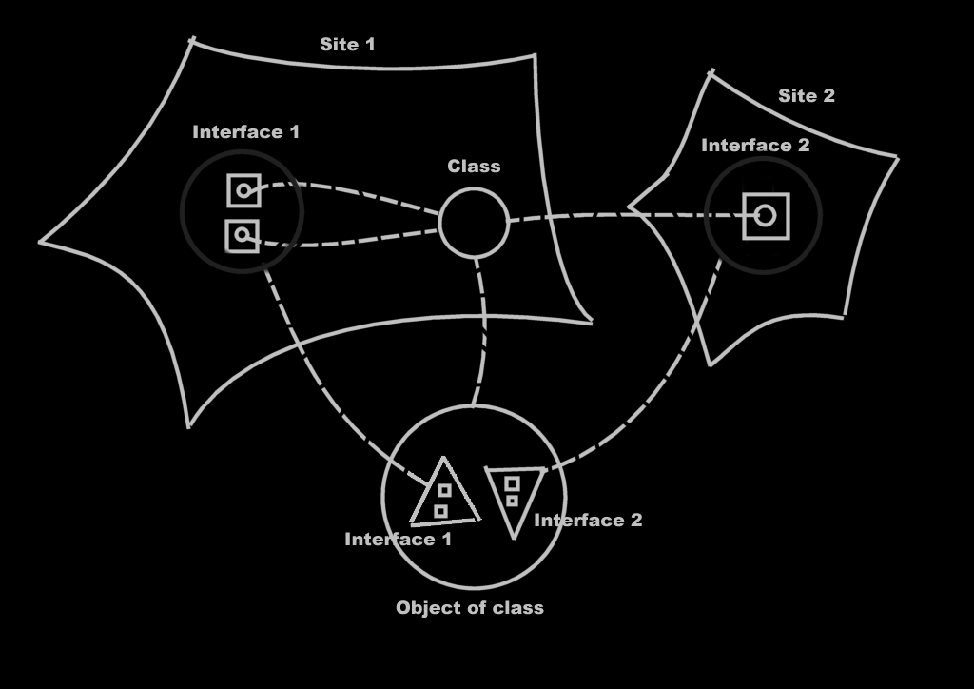

More Ideas

Access Control
On dual relations,
2008-09-06

If you establish a relation with another class, on another site,
then the other class gets a sub-item or sub-list as well.
So in that sense, an external class can change the interface
of a class on another site. So then, the interface is unreliable.
On one hand it is a welcome fact, that all new related objects
are <inzichtelijk> in the old class.
But a class can also access control the fact whether dual relations can be established to it.
In that case a class will not get a new related object when a new relation is established to it.
I think, that a dual relation has a source site. One end of the relation has authored the relation, the other relation just complied. Then the related object on the other site will have an interface of members established by another site.
Actually, this could happen dually: class A on site A has an interface of members, that reside on site B; class B on site B has an interfac eof members, that reside on site A.

JJ

Interfaces,
2008-09-06

Now that commands are objects, I have the following problem.
An object can be a normal object (a cirlce) and also one that melts together
with its parent object (a triangle). For command objects I have no way to express,
that the command object melts together with its parent.
This is an issue for interfaces.
> Yes you do. You put a triangle in a command.
> Ignore this ‘problem’

JJ

Out of the original Symbol documentation

Introduction, Interfaces
Another issue of objects is that they can have different interfaces. Consider how a employee looks to a customer and how she looks to one of her coworkers. She can do certain things for her coworker and much different things for a customer. She has two interfaces. The party that refers to her determines which interface she has, but even though both parties are referring to the same person, she means two totally different things to them.

Objects have the same ability. A type of object can have separate interfaces. Interfaces are groups of an object’s members. Another object that refers to the object decides which interface to use, or may even only be able to use a certain one of its interfaces. An object can also have just one interface, the same one for everybody.

Interfaces are distinguished by triangles.

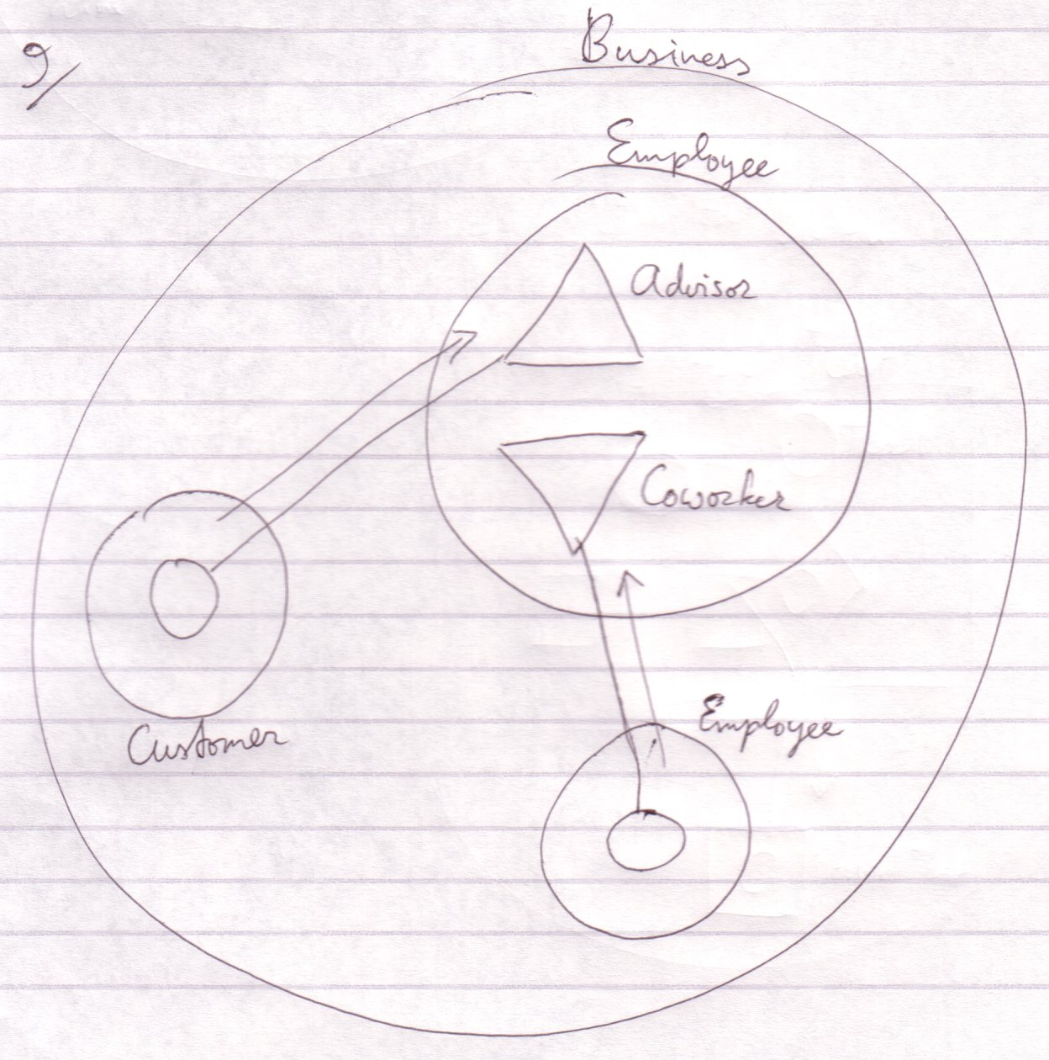

The employee is an advisor to the customer and to another employee a coworker.

Where to start when you read a diagram like this? You first read the containment structure. You start at the largest container, then the smallers ones. After that you look at the relations made by the connecting lines.

You don’t always start with the largest container. Sometimes one symbol is highlighted. Then this symbol is what the diagram is about and it's all about the aspects of this symbol. Then you start at the highlighted symbol and look around. There’s no one way of doing it.

Triangles are actually sub objects too. The difference with circles is that triangles basically melt together with their container.

Objects, be it triangles, are an excellent way to give different types mutual characteristics.

Object Basics Procedure Interface
A procedure has an interface too, consisting of all public contents of the procedure: public objects (in, out or thru) and public procedures (clauses, calls and references). A procedure can have an interface line. The target of this interface line must be a procedure, in case of which both procedures get the same parameters.


Procedure with an external interface

The interface source for a procedure can only be a procedure, not an object. Also: a procedure can not have multiple interfaces. The effect of allowing these two things can be imagined, but the usefulness of these structural possibilties is slim, while it would add a lot more rules to the Symbol Language.

For the time being, triangles can reside in a procedure, but only for the purpose of grouping procedure members. You can’t give these triangle any lines, because that would suggest that the procedure adopts all characteristics of an object.

Interfaces
Every symbol has an interface. The interface is represented by the public contents of the symbol. Anything private is the implementation of the interface.

In a normal procedure, for instance, the code lines of it are actually private and part of the implementation. Only the procedure name, its parameters and return value are public and are part of the interface.

So a symbol always has an interface: its public members.

To make two symbols have the same interface you connect them with a dotted line:



This dotted kind of line is also called an interface line, because it denotes which symbols have the same interface. The public members of both symbols are the same, but each symbol has its own implementation. The symbols are not necessarily the same type nor the same object.

This way you can give a type an already defined interface. That for instance allows objects that can work with a certain interface, to link to objects of the new type.

Editing the interface can be kind of dangerous, because if you remove an interface member, you remove all the implementations of the member in all the types that have that interface. If you do edit an interface, then the interface of the connected symbols changes simultaniously, but not the implementation.

> Fundamental Principles,
2010-05-07

If everything starts out freely definable, then you make a system by creating restrictions. So systematics are defined through restrictions. If there are not restrictions, you can program anything programmable. After you create a system of classes, someone else may create a system of objects, in which not everything is programmable, but only very specific things are programmable.

JJ

Two Interfaces
You also have the ability to give a symbol two separate interfaces. For this, the triangle symbol is taken in use.

The following is the basic notation for a symbol that implements two separate interfaces:



A triangle represents the implementation of an interface. Triangles are, however, often called interfaces of the object. Don’t start to think that only triangles are interfaces. Any symbol can function as an interface. A triangle is the implementation of an interface.

Triangle Versus Circle
A triangle, just like the circle, is a:

- Type
- Object
- Interface source
- Creatable (explained soon)



Using a triangle instead of a circle:



Sees to it that:

- B’s members are accessed as if they were A’s own members
- You can refer to type A as if it were of type B



So a triangle is a sub object of the container, but its members are like part of the container and the container can be referred to as if it has the type of the triangle.

Member Grouping
Because a triangle basically merges with its container, it’s like you aren’t bothered by the borders of a triangle. That makes the triangle an easy way of grouping members, without harming the way you access the members.

You can also put a circle around members to group them. That changes the way you access the members, though. You’d have to qualify the access with the name of the grouping circle.

A Circle Contains But Interface Implementations
Each circle implements at least one interface. Nothing is defined outside the context of an interface implementation so inside a circle nothing else can be defined but a set of interface implementations and the interface implementations contain the rest.

Since a triangle represents an interface implementation and a circle contains but interface implementations you’d think that a circle contains at least one triangle: one interface implementation. A circle, though, is itself an interface implementation and triangles are merely used to distinguish between separate interface implementations.

A circle:



is not shorthand for:

because the triangle is its own object. The first diagram shows one object and the second diagram shows two.

Executions & Parameters

Brainstorm

→Elsewhere
Procedure Interface Restrictions
<>
A procedure has an interface too, consisting of all public contents of the procedude: public objects (in, out or thru) and public procedures (clauses, calls and references), which can also be individually referenced and called.

The interface source for a procedure can not be an object symbol. Also: a procedure can not have multiple interfaces. The effect of allowing these things can be imagined, but the usefulness of these structural possibilties is slim, while it would add a lot more rules to the Symbol Language.

For the time being, triangles can reside in a procedure, but only for the purpose of grouping procedure members. You can’t give these triangle any lines, because that would suggest that the procedure adopts all characteristics of an object.

The procedure has no interface genericity. <A word not introduced yet here. <You can’t redirect the interface of a triangle inside a procedure either, because this would suggest that a procedure gets object characteristics. This is a restriction of a triangle directly inside a procedure symbol. >

<I think I’m totally nervous about public procedure clauses. And that’s why I forbid interface redirection for triangles in procedures here. I should allow it. The only thing disallowed is interface genericity, because that would suggest that a triangle in a procedure can point to a procedure symbol.

Hmmm… @#$.>
<A lot isn’t right in what I just said there>

< The rules I will suggest in this section can change the Procedure Basics : Procedure Interface section. >

Other
Er moet ergens nog in dat een procedure een interface heeft. En misschien moet een procedure daarom ook een interface line krijgen.

Brainstorm
J Code Access Controllers and Interfaces.
------------------------------------------------

You should be able to group symbols inside a special symbol that controls the access for all the directly contained symbols. <2010-05-07 Just use a triangle and access control the triangle.> An idea is to make a special symbol to control the access for all the directly contained symbols. What pops into my head now is: since the triangle would then stand for interface, each member with the same access controller could belong to the same interface. Therefore, an interface symbol (triangle) could be used to group these symbols and the interface symbol gets the access controller instead, which applies it to all directly contained symbols.

Groeperingssymbool op basis van wat een client object gebruikt. De interface indeling is op die manier een beetje automatisch. <2010-05-07 Move this idea to extensive classification through interfaces.> Als je geen interface indeling hebt, dan kun je toch zien wat de verschillende clients gebruiken en misschien voor het overzicht toch een interface indeling gebruiken.

Interface
< 2008-10-10 Old >
I said a triangle was an interface. Eigenlijk is de interface een hoop functie referenties die ingevuld moeten worden. Dan zou het zo zijn dat alle members in een driehoek door zouden moeten refereren naar members binnen de cirkel. Eigenlijk moet ik een driehoek zijn eigen syntax laten hebben. Een driehoek krijgt een interface klasse. Deze kan een cirkel zijn of driehoek. De driehoek krijgt de publieke en vriendschappelijke inhoud van de interface klasse, maar niet de prive inhoud, welke de implementatie omvat. Dus de implementatie ontbreekt. Je kunt deze of zelf invullen of je creeert de implementatie door de driehoek te creeeren met een bepaalde implementatie klasse, waardoor je inheritance bewerkstelligt. Je kunt evengoed de verwijzing van de driehoek veranderen om de implementatie te delegeren. De driehoek heeft altijd de holle vorm van zijn interface klasse, maar de klasse en het object van zijn verwijzing. Als je hem creeert dan heeft hij geen verwijzing.

Een interface heeft een interface, implementatie en object. De klasse is de interface, de implementatie zou ook een klasse moeten zijn en het object dan de referentie.
Heeft de driehoek een extra referentie dan? Interface, implementatie en object?

Maar dan heeft een cirkel dat ook, want die representeert… oh, de gezamenlijke interface. De driehoek kan ook zelf de interface klasse zijn en de interface en de implementatie.

Changing a Reference or Type
An object assignment procedure gets the source as an argument, and another argument that specifies the symbol to reference. The symbol to reference needs to be the same interface …
A reference has a fixed interface, but can be point to or be of any type as long as you reference the same interface.
For that, changing the type of a reference is permited

Changing the type of a symbol is not permitted, be it that the same interface of

2004,

You might not want to be able to reference a type’s full interface, but only the sub interfaces, so it would be more like com. Oh, this actually seems an access control issue.

JJ

2004,

Symbol has to be revised. It doesn’t distinct types and interfaces well. It doesn’t work well with interfaces. Like how do I pass a pointer one interface of an object to a method?

JJ

2004,

A type has one interface by default: the default interface, which is formed by every public member of the type. A type can also have multiple interfaces, which are groups of its members. The default interface includes all members of these separate interfaces.

JJ

Terms
Interface
Implementation

-----

-----

2008-10-13,

2004: “Methods abstract other methods”
Perhaps Interfaces should cover a lot of design patterns as such, even though they do not directly have to do with interfaces

JJ

Similarly, an object symbol can control its own interface:

But if it has an interface line, its interface is bound to that of its interface line target. The symbol is regarded an interface implementation, while the target interface serves as the interface.


B is the interface, A is an implementation of it.

More Ideas
Interfaces,
Commands / Computer Language,
2009-03-13

Commands on an object do not have a sub-grouping of commands.
There is just one big group of commands... is there? Isn't it grouped by interface or something?
In a context-menu you can have commands grouped together.

JJ

